**Report lab 8**

8.3:

Program 1: Output File Data to FIFO File

* This program takes a file path as a command-line argument.
* It opens the specified file in read-only mode using the open() system call and retrieves a file descriptor (fileToReadFd).
* It opens the FIFO file for writing only using the open() system call and retrieves a file descriptor (fifoFd).
* The program then reads data from the input file in chunks of BUFF_SIZE bytes using the read() system call.
* The read data is written to the FIFO file using the write() system call.
* This process continues until there is no more data to read from the input file.
* Finally, the file descriptors are closed using the close() system call.

Program 2: Output FIFO File Data to Console

* This program opens the FIFO file in read-only mode using the open() system call and retrieves a file descriptor (fifoFd).
* It then reads data from the FIFO file in chunks of BUFF_SIZE bytes using the read() system call.
* The read data is written to the console (stdout) using the write() system call.
* This process continues until there is no more data to read from the FIFO file.
* Finally, the file descriptor is closed using the close() system call.

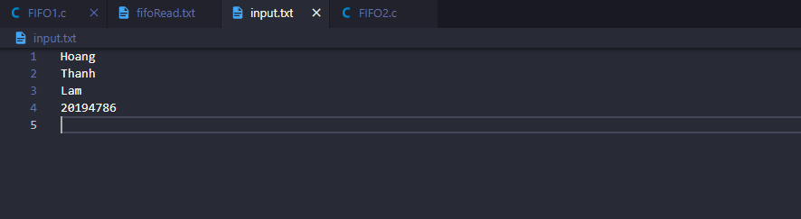

Result:

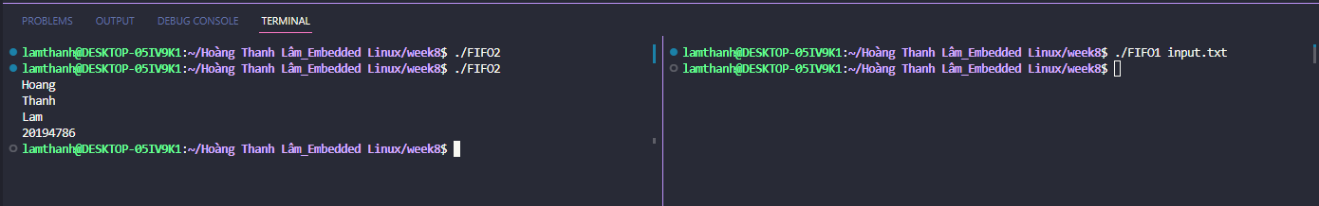

8.4:

* Run Program 1 first. It will decrement the semaphore value and output an arbitrary character string.

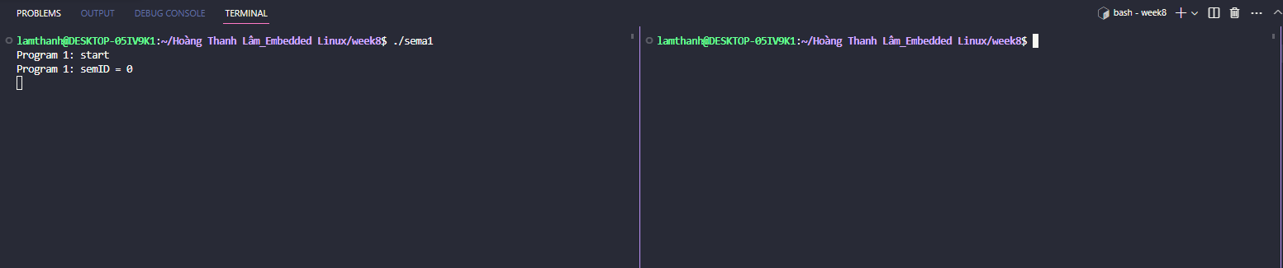

* Run Program 2 after Program 1. It will increment the semaphore value and output another arbitrary character string.

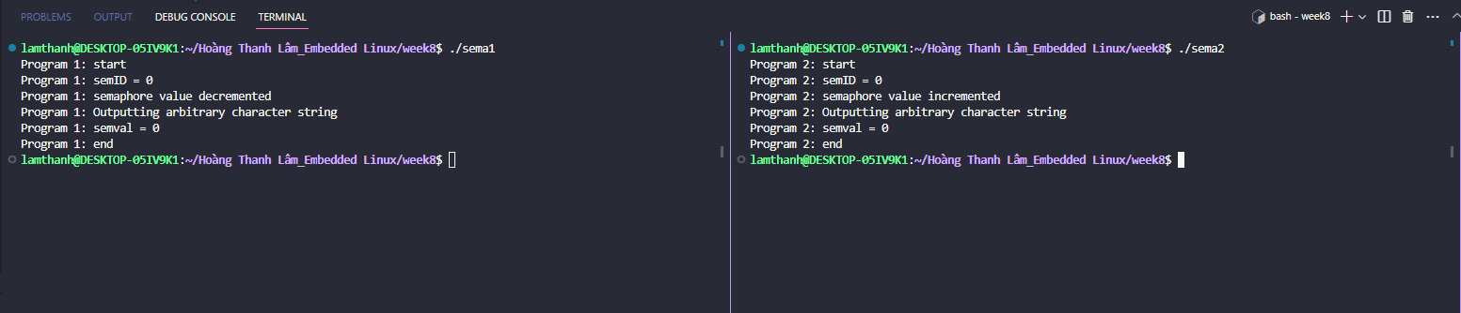

* After the programs finish executing, run the ipcs -s command to check if the semaphore array remains. The semaphore array should be removed automatically after the programs exit.

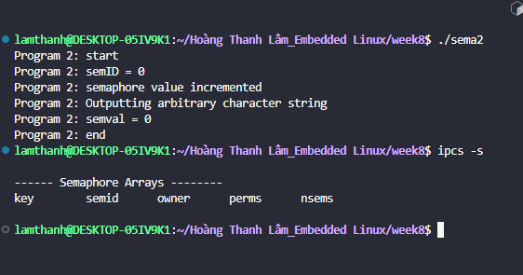

8.5:

1. Run the program1 and waiting for input enter.



1. Run program2. Confirm becoming the mutex unlock waiting of the program1.



1. Input Enter in the program1. Confirm program1 is unlocked.